1. Part 1 — Hands-On Practice (Approx. 70 min)
A. Initialize and Configure (10 min)
- Create a folder named day1_day2_practice.
- Initialize Git and check for the .git folder.
- Configure username + email (locally).
git init
git config user.name "Your Name"
git config user.email "your@email.com"
git config --list --local
📝 Deliverable → Screenshot showing git init and git config output.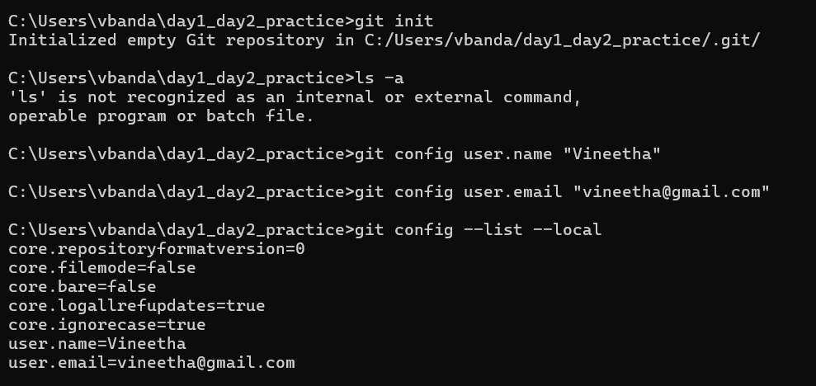
. File Lifecycle (25 min)
- Create three files:
intro.txt setup.txt notes.txt
- Add some text to each.
- Stage only intro.txt and setup.txt.
git add intro.txt setup.txt
git status
- Edit intro.txt again without re-adding.
- Compare results of:
git diff
git diff --staged
- Commit staged files:
git commit -m "First commit - intro and setup"
📝 Deliverable → In 2–3 sentences, explain why the second edit to intro.txt didn’t go into the commit.

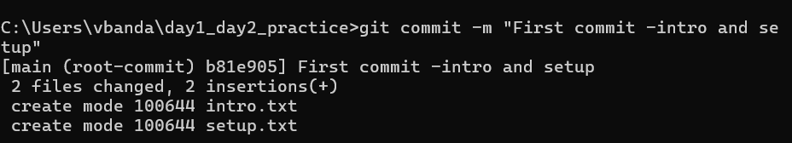
Ans: The second edit to intro.txt didn’t go into the commit because Git only commits changes that are staged. After staging the first version of intro.txt, I made another edit but didn’t run git add again, so the new change stayed in the working directory.
Part 2 — Conceptual Quiz (Approx. 40 min)
1.What happens inside Git when you run git add file.txt?
Ans:Git takes the current version of file.txt and adds it to the staging area so it’s ready for the next commit.

2.Why do we say a commit is a snapshot, not a diff?
Ans:Because Git saves the entire state of all tracked files at that moment, not just the changes.

3.What is stored inside the .git folder?
Ans:It contains all Git metadata: commits, branches, tags, configuration, and object database.

4.What does HEAD point to, and how is it updated?
Ans:HEAD points to the current branch’s latest commit and updates when you commit or switch branches.

5.What’s the difference between the Working Directory and the Staging Area?
Ans:The working directory has your actual files; the staging area holds the versions you plan to commit.

6.What happens if you change a file after staging it?
Ans:The new changes stay in the working directory and won’t be committed unless you stage them again.

7.Why doesn’t Git store whole files for every commit?
Ans:To save space, Git stores files as objects and reuses unchanged data using hashes.

8.What is version control, and how does Git make it easier?
Ans:Version control tracks changes over time; Git makes it easy by allowing branching, merging, and history tracking.

9.What are tracked vs untracked files?
Ans:Tracked files are under Git’s control; untracked files are new and not yet added to Git.

10.Write the complete flow of commands from creating a repo to committing your first file:
Ans:
mkdir myrepo
cd myrepo
git init
echo "Hello" > file.txt
git add file.txt
git commit -m "Initial commit"

